Silhouette metric for img016001.jpg is: 0.8133147106507582

Davies Bouldin metric for img016001.jpg is: 0.2215460254565718

Calinski Harabasz metric for img016001.jpg is: 553.8010376432499

ID 0: (1680, 693)

ID 1: (1676, 714)

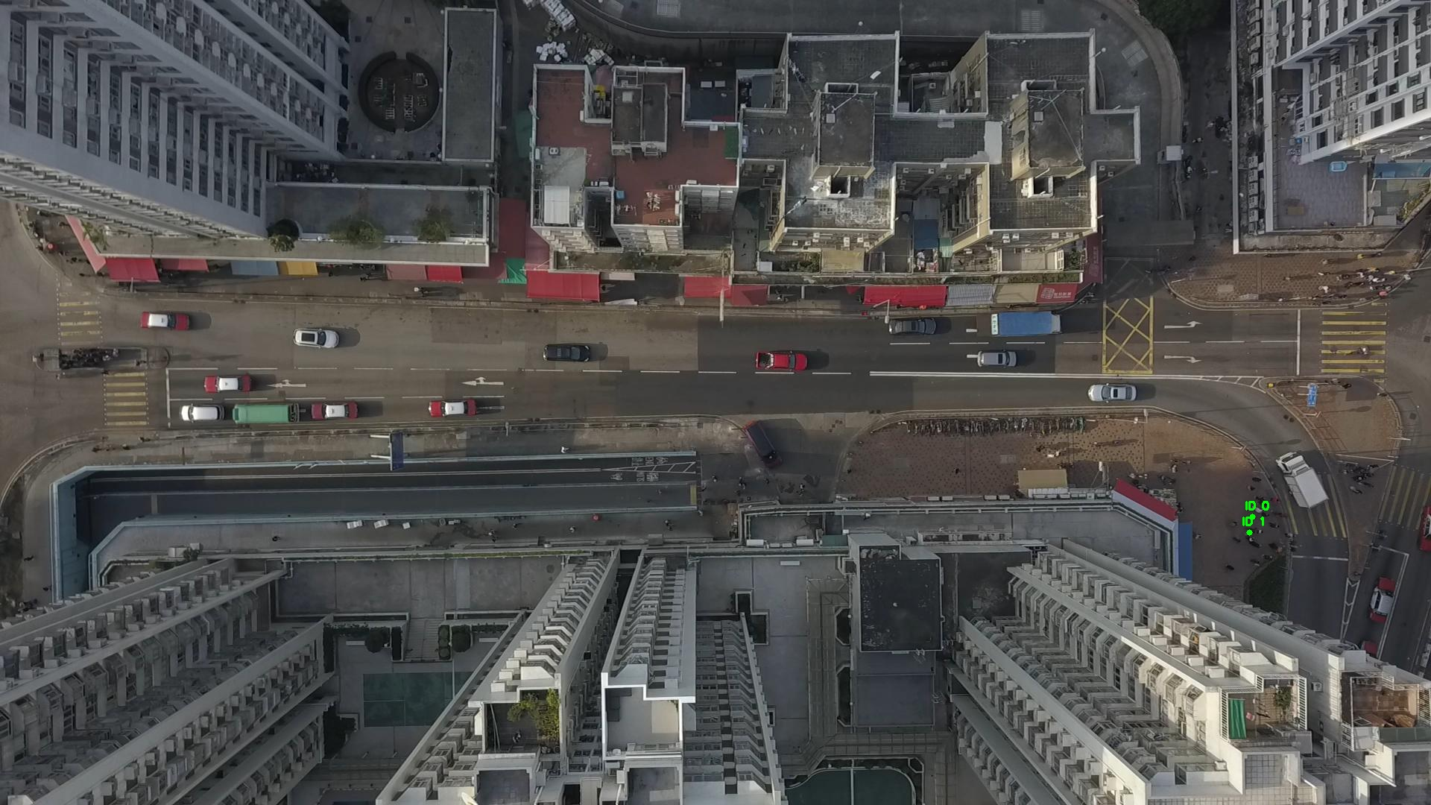

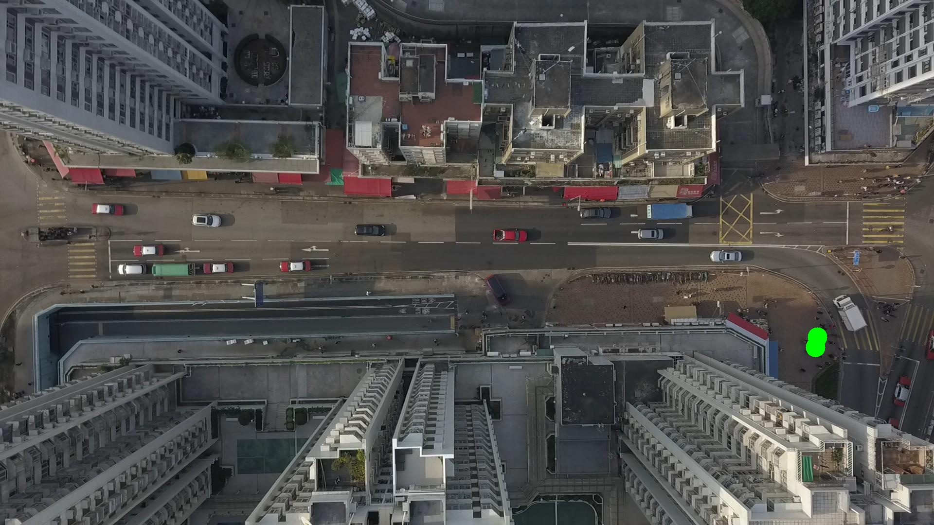

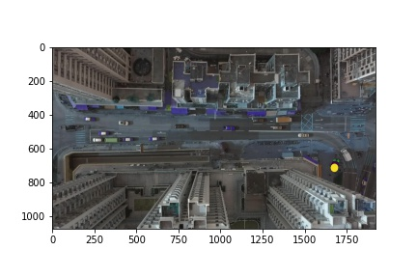

Silhouette metric for img016002.jpg is: 0.09160775965339603

Davies Bouldin metric for img016002.jpg is: 2.1355219720074676

Calinski Harabasz metric for img016002.jpg is: 8.68863845827509

ID 0: (1676, 711)

ID 1: (1676, 713)

ID 2: (1676, 715)

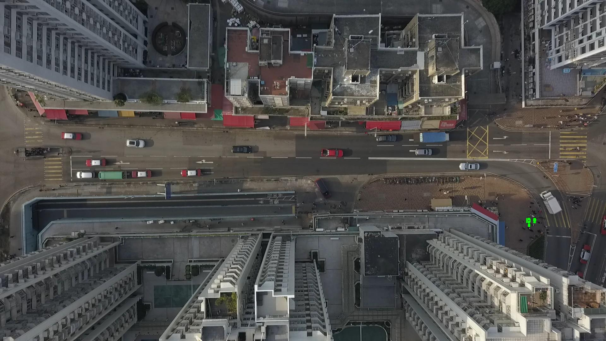

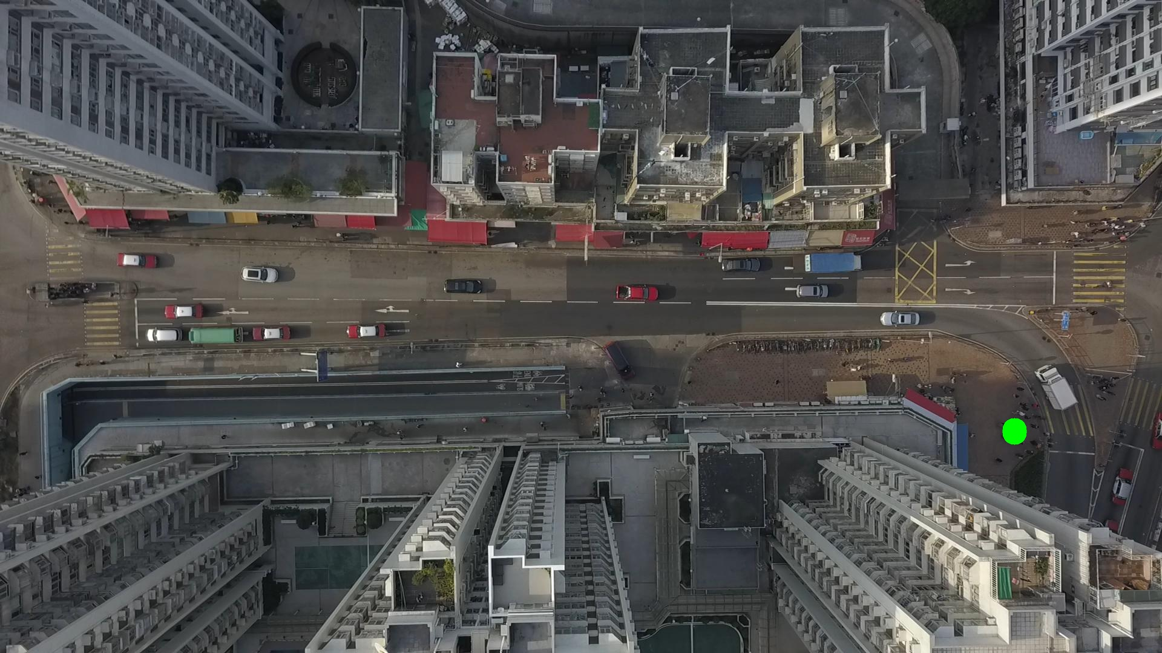

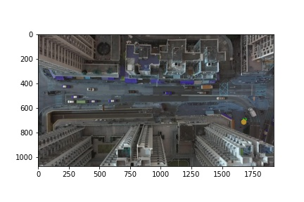

Silhouette metric for img016003.jpg is: 0.7645811060328566

Davies Bouldin metric for img016003.jpg is: 0.28371686770191906

Calinski Harabasz metric for img016003.jpg is: 630.1668147360967

ID 0: (1676, 711)

ID 1: (1676, 713)

ID 2: (1677, 715)

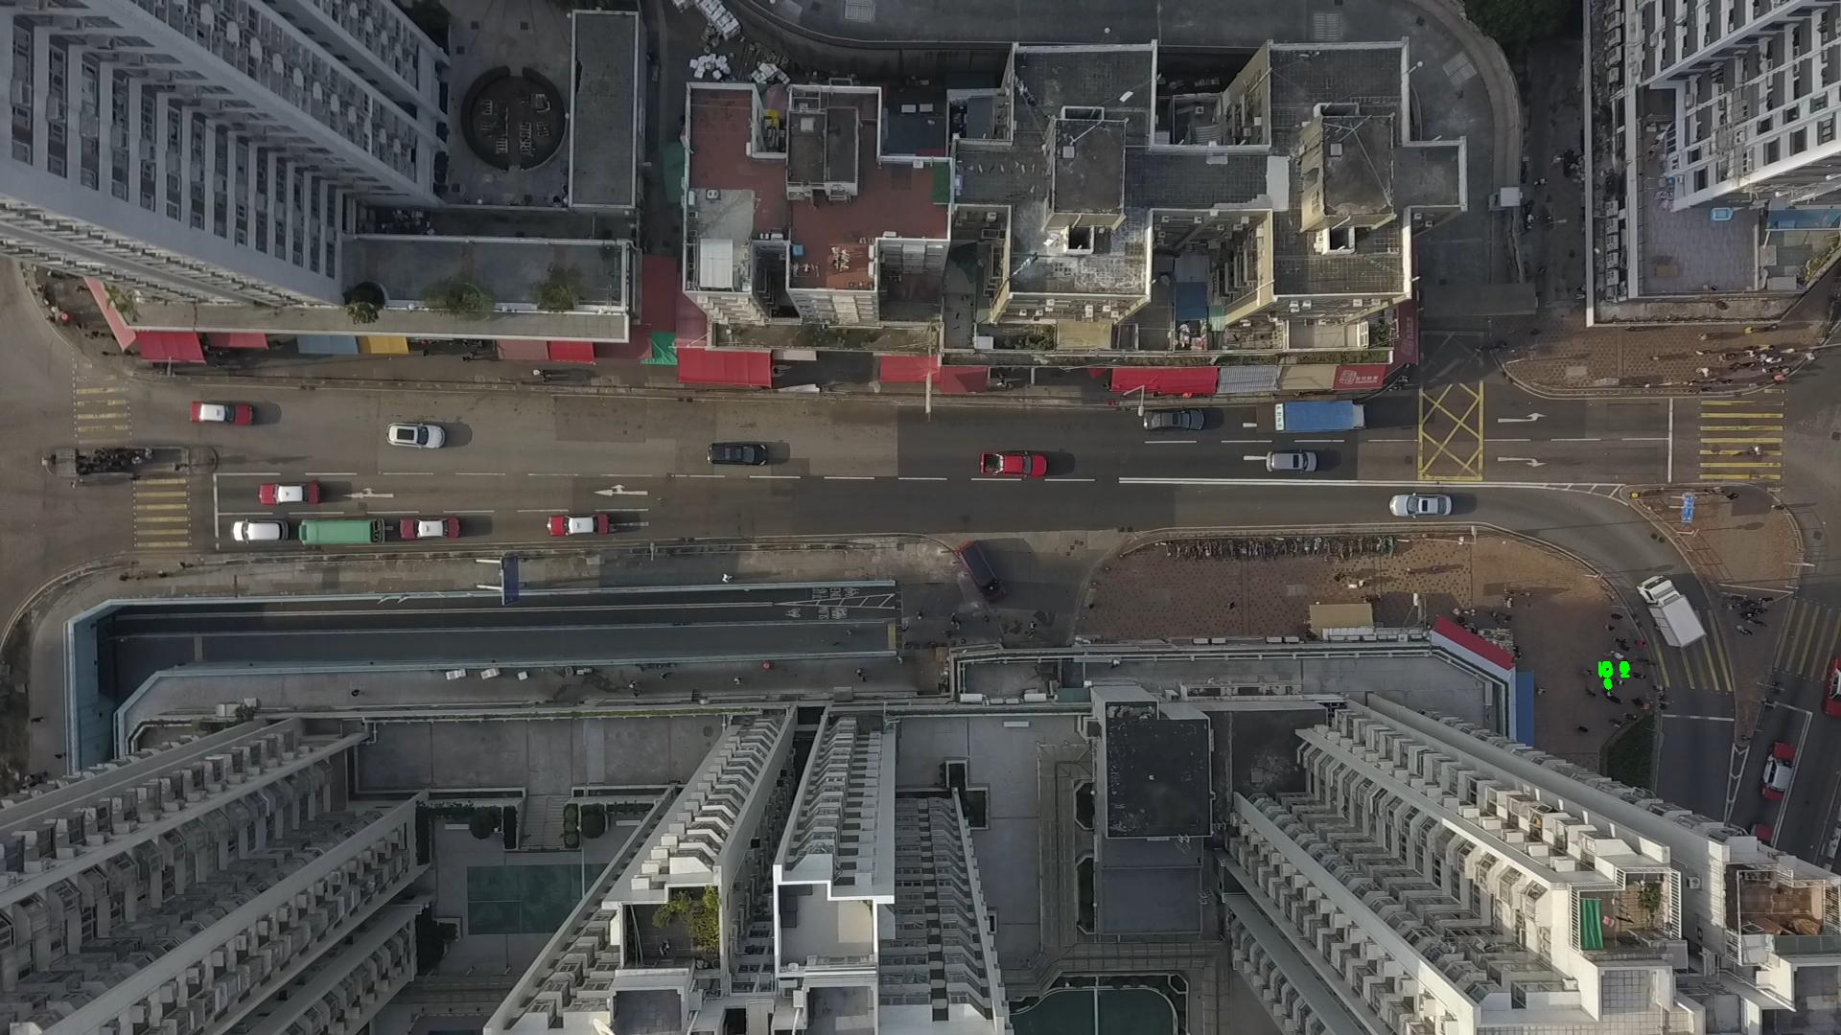

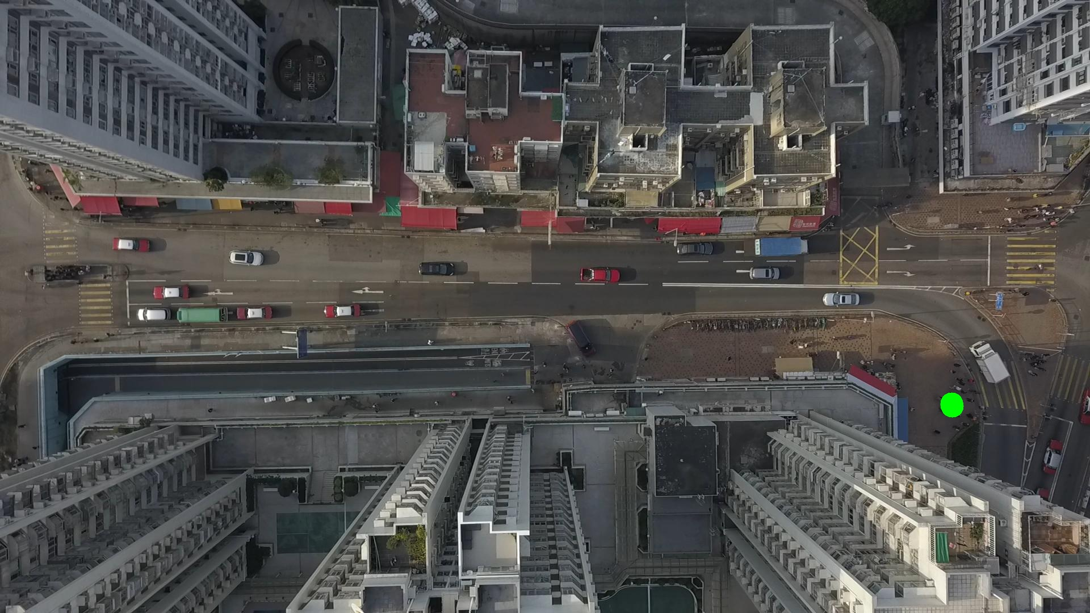

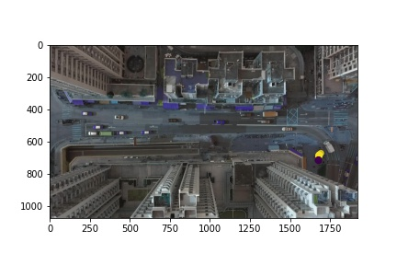

Silhouette metric for img016004.jpg is: 0.8437713053346633

Davies Bouldin metric for img016004.jpg is: 0.22393177064822678

Calinski Harabasz metric for img016004.jpg is: 1467.4563737811584

ID 0: (1676, 711)

ID 1: (1676, 713)

ID 2: (1676, 716)

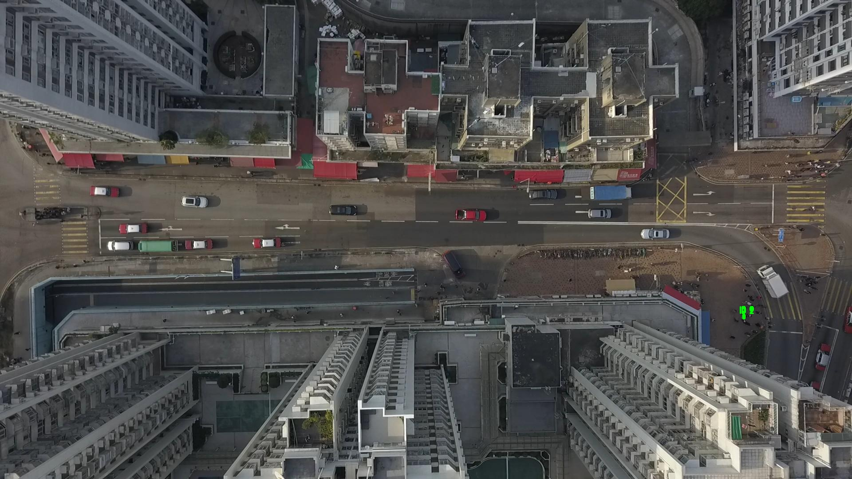

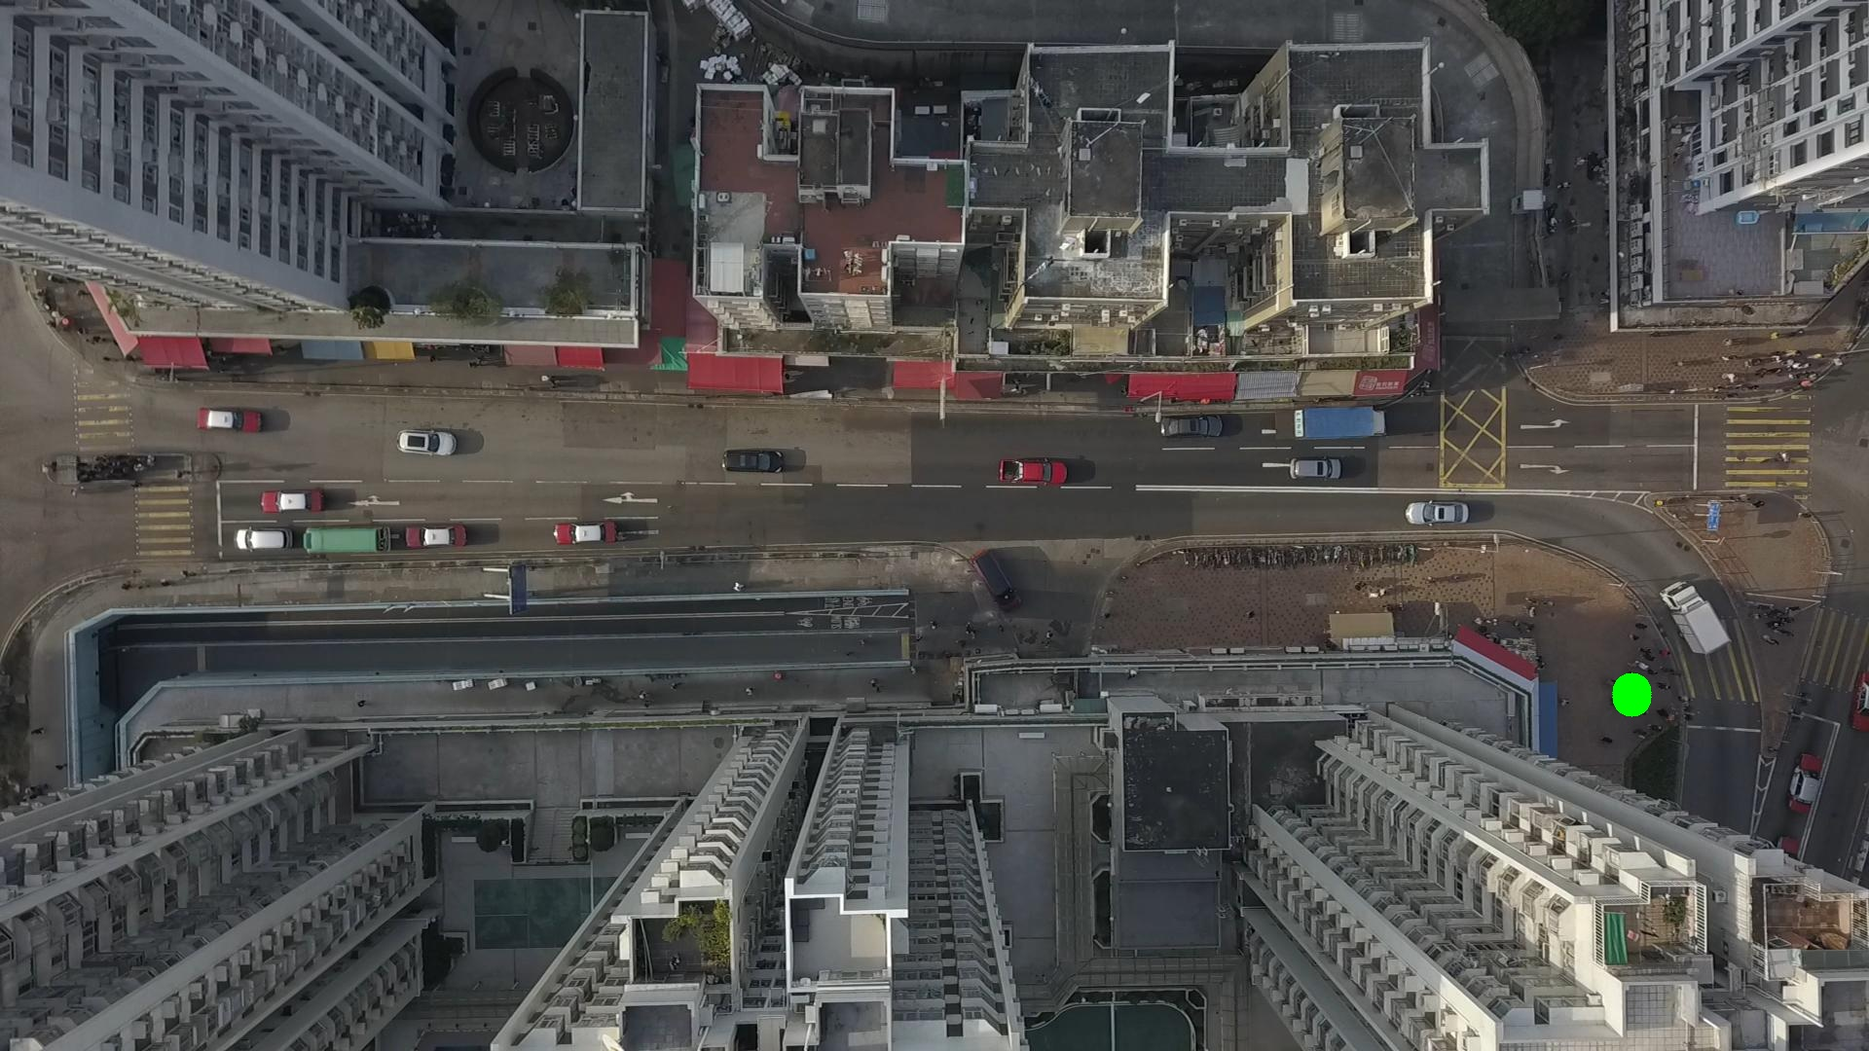

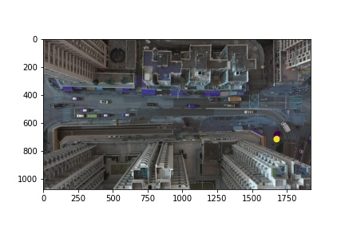

Silhouette metric for img016005.jpg is: 0.8569804337788809

Davies Bouldin metric for img016005.jpg is: 0.12844955976433436

Calinski Harabasz metric for img016005.jpg is: 89988.2122117749

ID 0: (1676, 711)

ID 1: (1676, 713)

ID 2: (1676, 717)

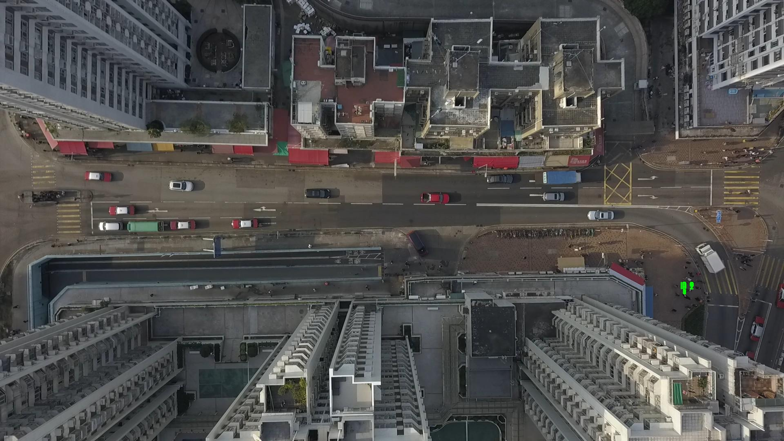

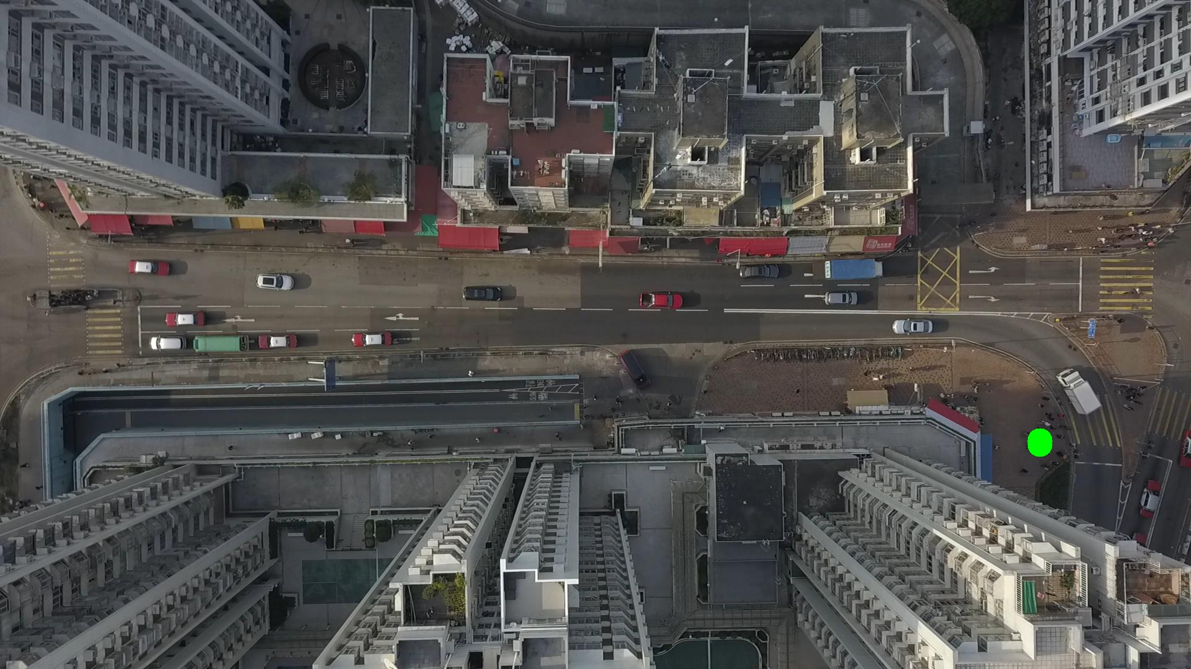

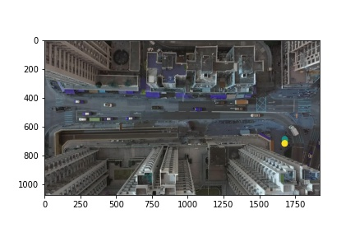

Silhouette metric for img016006.jpg is: 0.9901571915864265

Davies Bouldin metric for img016006.jpg is: 0.01319354554031692

Calinski Harabasz metric for img016006.jpg is: 297086.326305704

ID 0: (1676, 706)

ID 1: (1676, 713)

ID 2: (1676, 717)

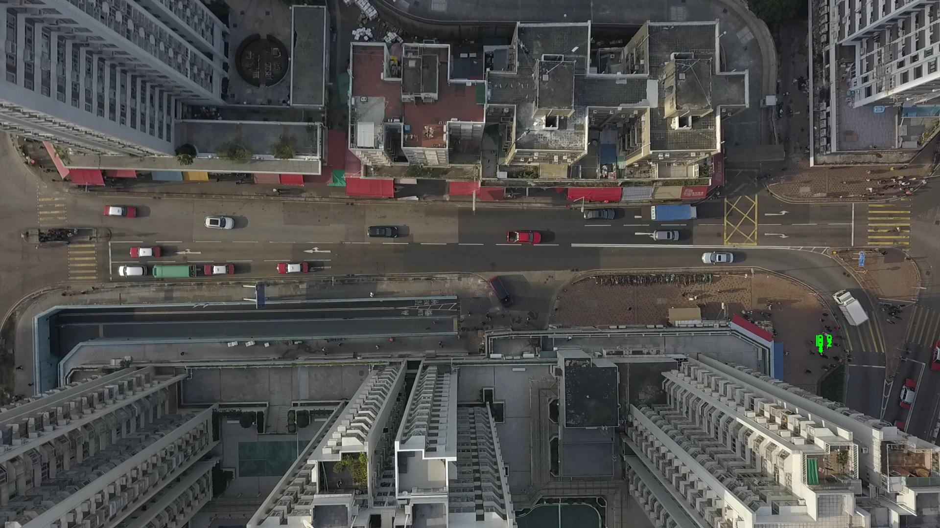

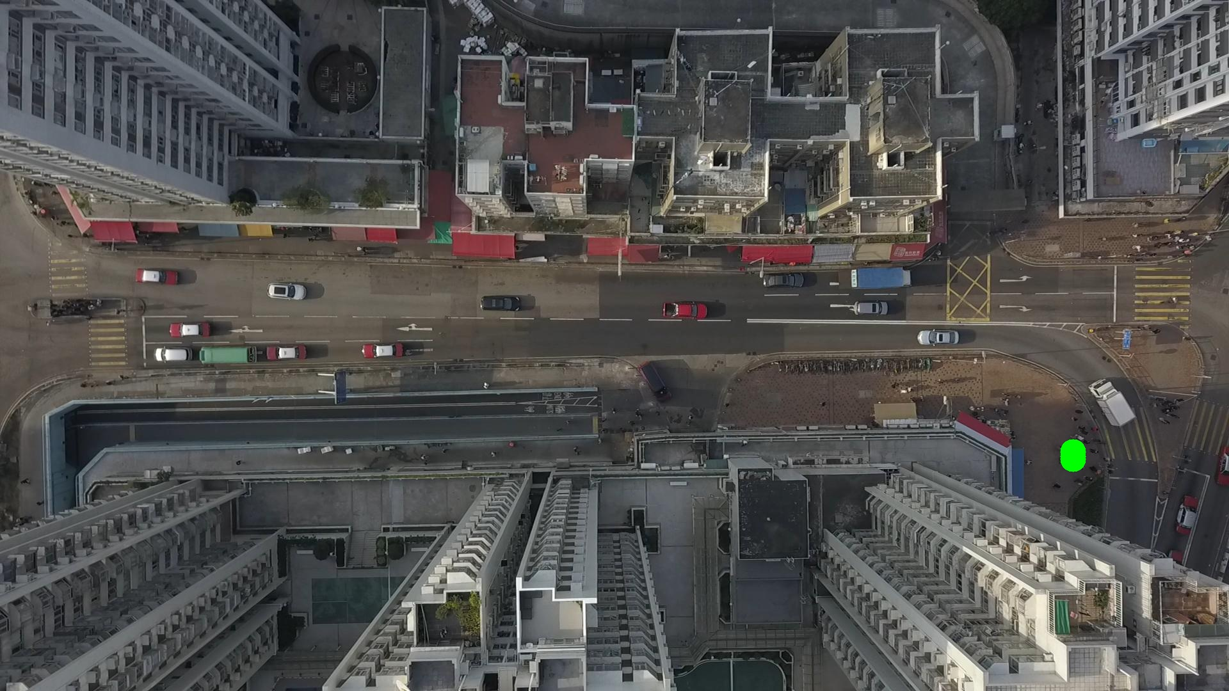

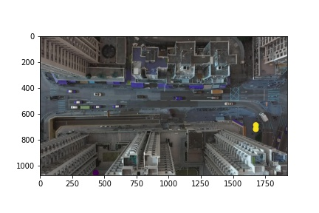

Silhouette metric for img016007.jpg is: 0.9028205948230001

Davies Bouldin metric for img016007.jpg is: 0.0984243812469799

Calinski Harabasz metric for img016007.jpg is: 792.0543808048387

ID 0: (1676, 701)

ID 1: (1676, 713)

ID 2: (1676, 717)

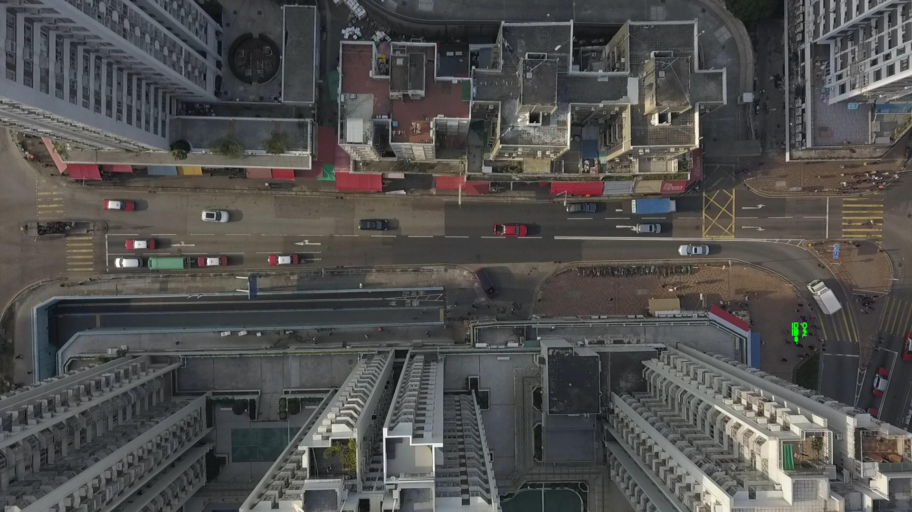

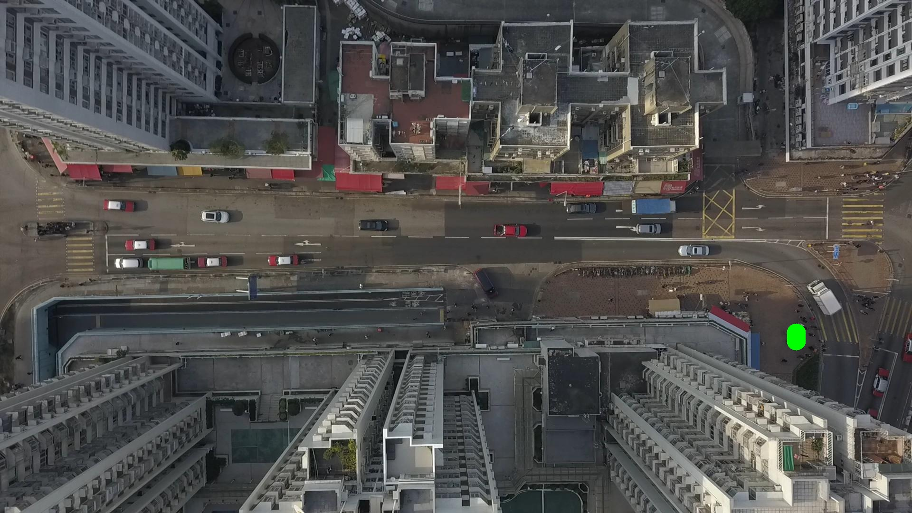

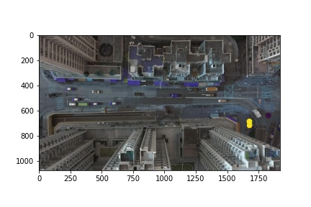

Silhouette metric for img016008.jpg is: 0.8975386776825689

Davies Bouldin metric for img016008.jpg is: 0.08872857347937864

Calinski Harabasz metric for img016008.jpg is: 1300.6450541189258

ID 0: (1683, 683)

ID 1: (1676, 713)

ID 2: (1676, 717)

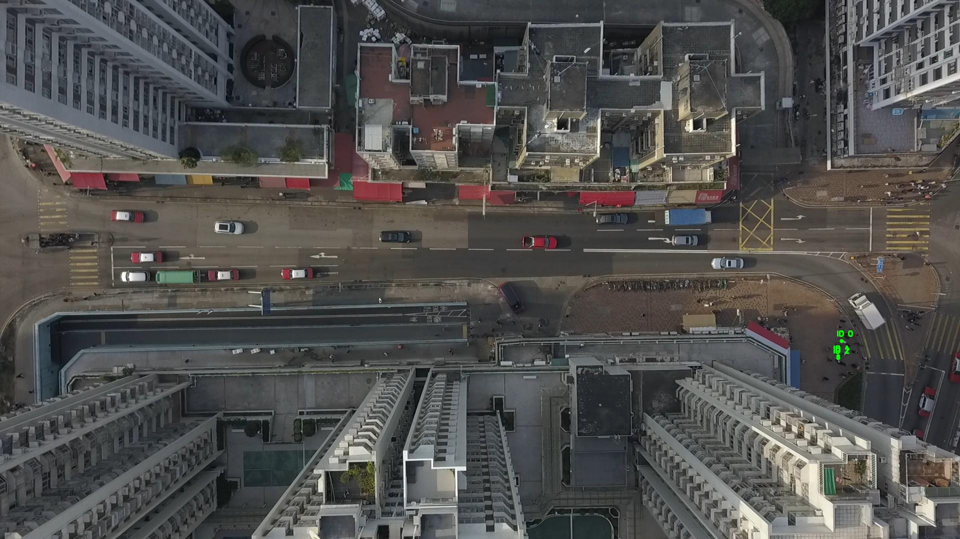

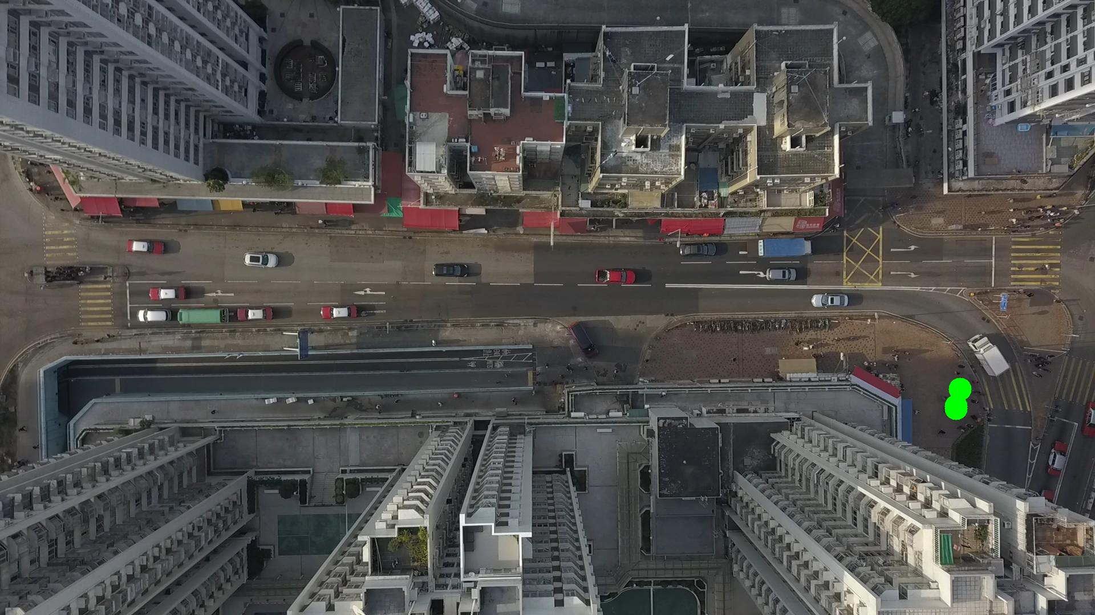

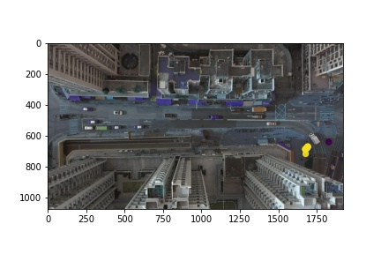

Silhouette metric for img016009.jpg is: 0.9527378112139584

Davies Bouldin metric for img016009.jpg is: 0.07793181587155737

Calinski Harabasz metric for img016009.jpg is: 16057.292529572935

ID 0: (1687, 676)

ID 1: (1676, 713)

ID 2: (1676, 717)

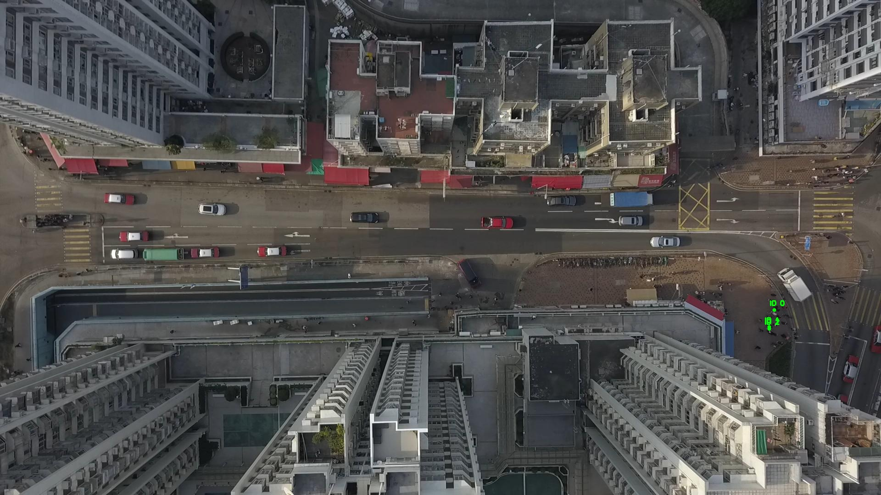

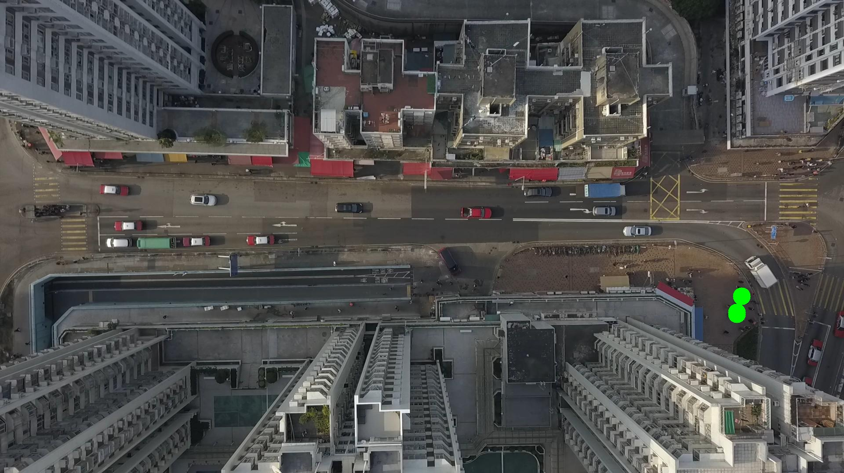

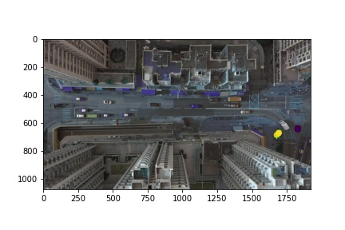

Silhouette metric for img016010.jpg is: 0.9744213227222601

Davies Bouldin metric for img016010.jpg is: 0.03679877010958735

Calinski Harabasz metric for img016010.jpg is: 57287.234373488085

ID 0: (1690, 673)

ID 1: (1676, 713)

ID 2: (1676, 717)

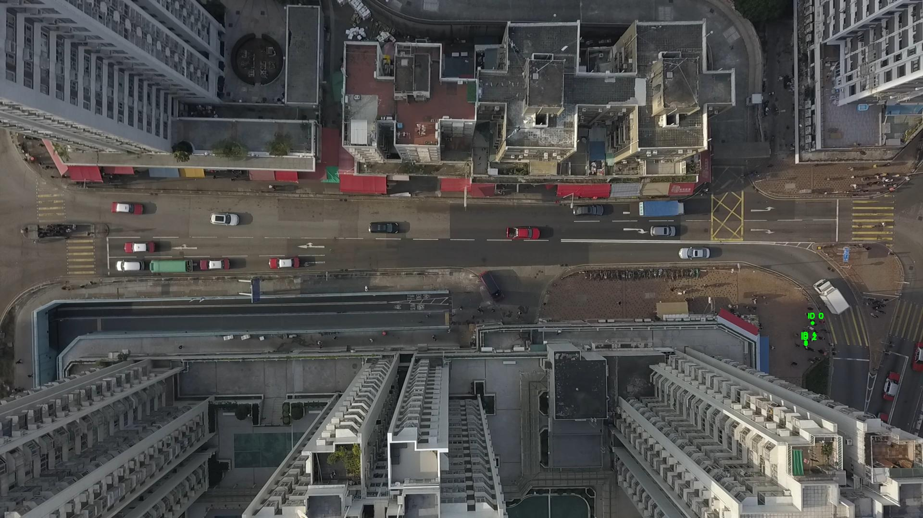

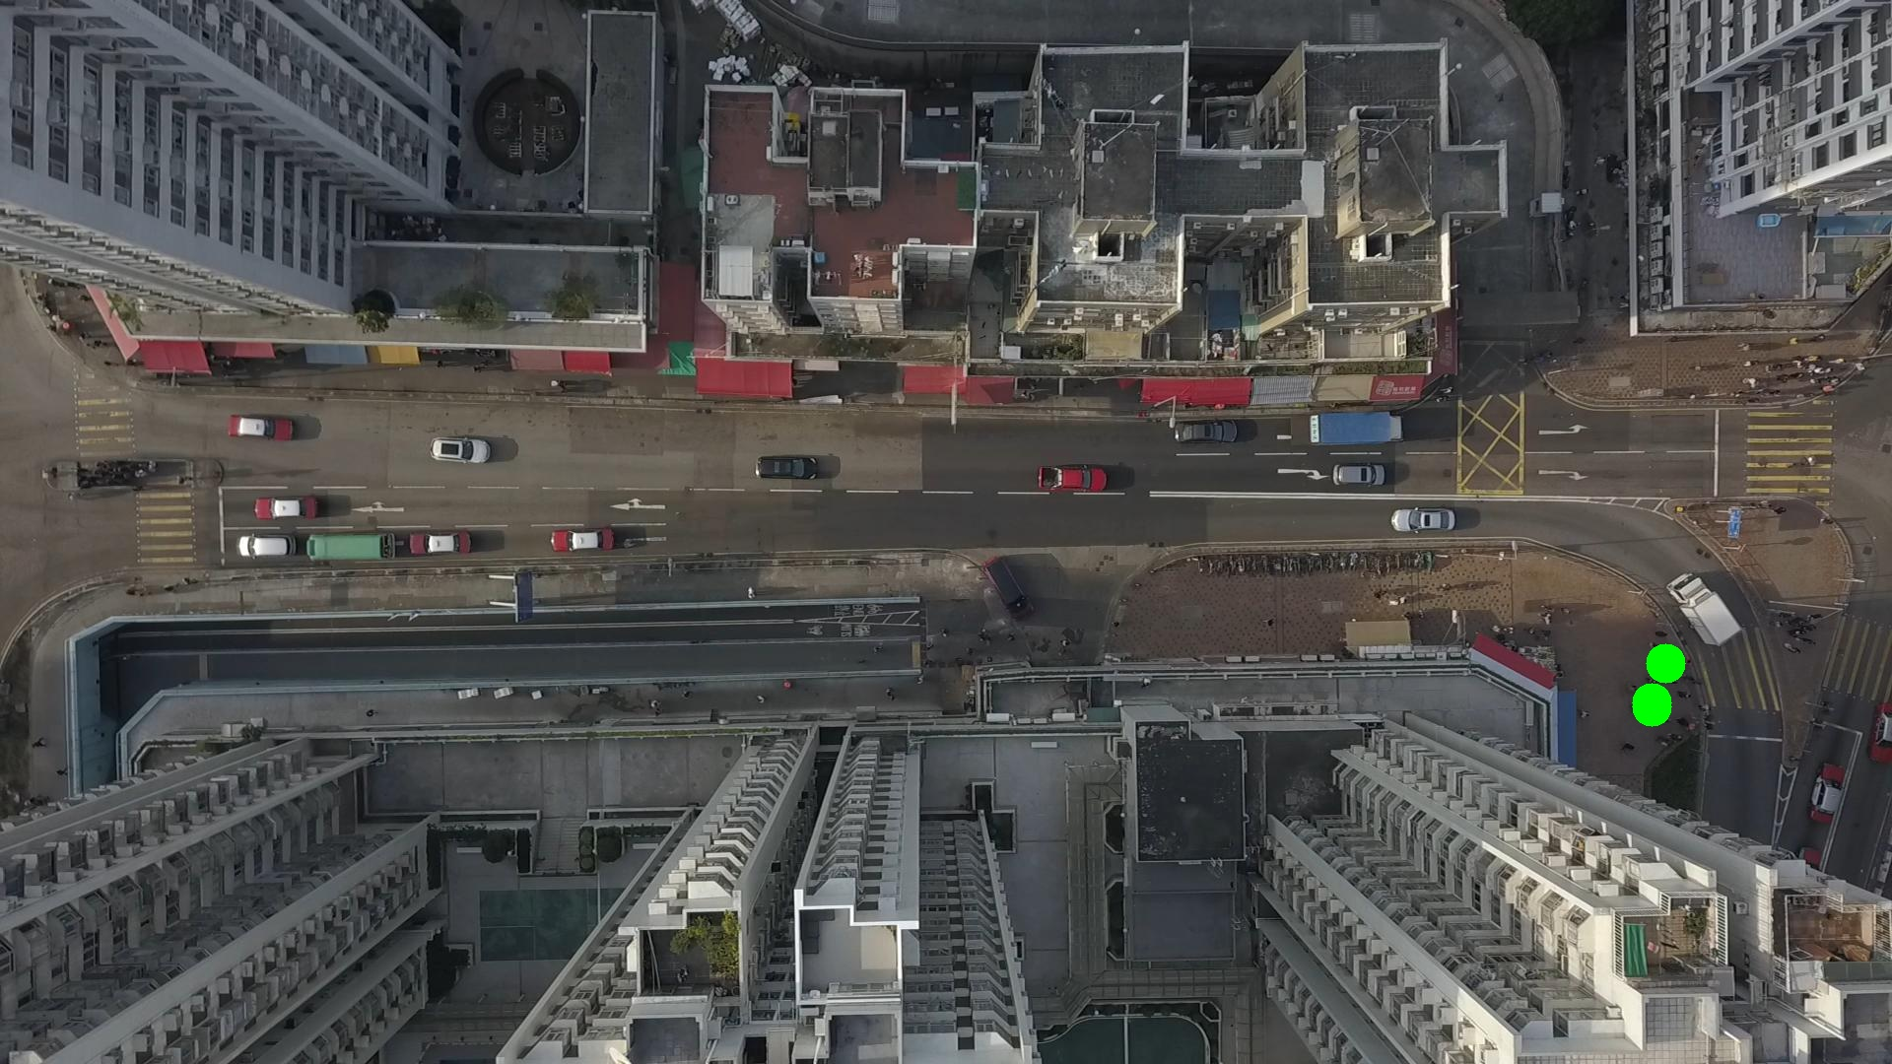

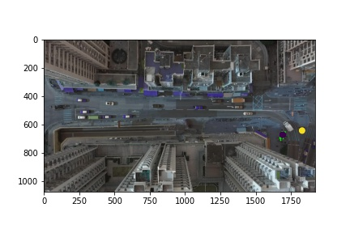

Silhouette metric for img016011.jpg is: 0.974409594301472

Davies Bouldin metric for img016011.jpg is: 0.03607181128634161

Calinski Harabasz metric for img016011.jpg is: 45682.410276473696

ID 0: (1691, 672)

ID 1: (1676, 713)

ID 2: (1676, 717)

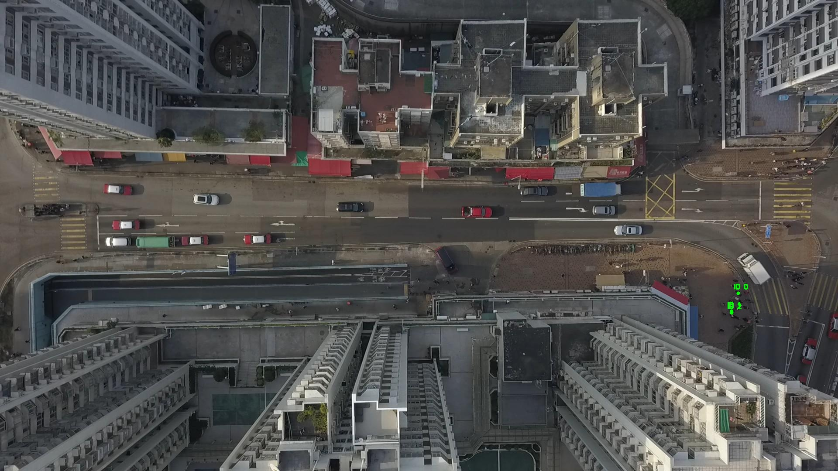

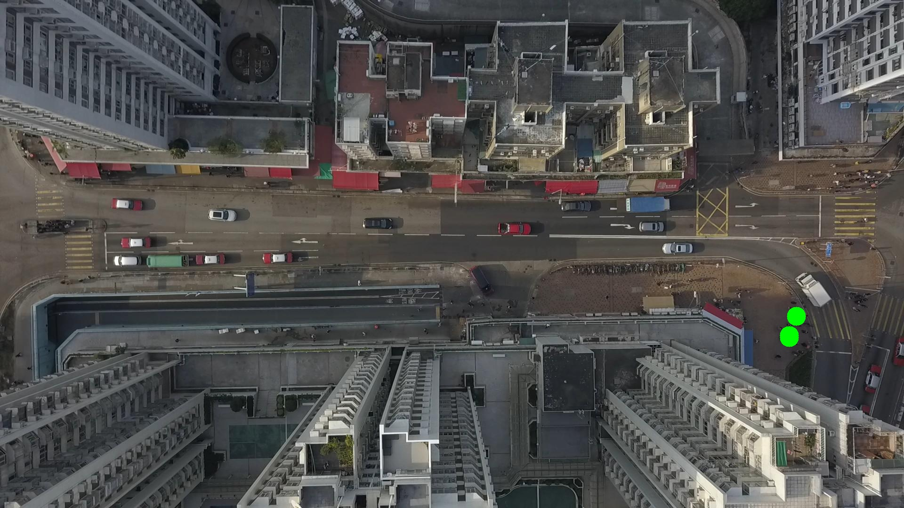

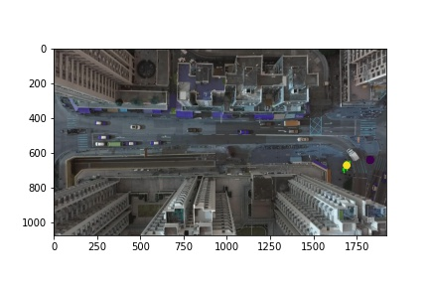

Silhouette metric for img016012.jpg is: 0.08885339693626787

Davies Bouldin metric for img016012.jpg is: 5.755320032980074

Calinski Harabasz metric for img016012.jpg is: 3.3008728743748406

ID 0: (1691, 672)

ID 1: (1693, 673)

ID 2: (1676, 717)

